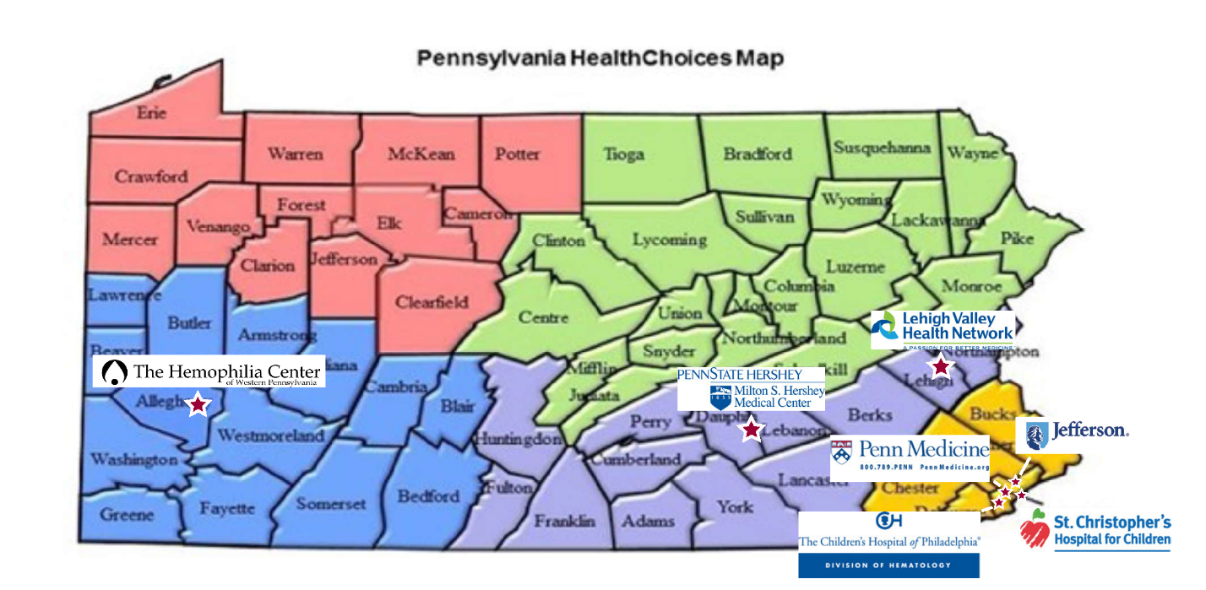

The Specialty Care Programs funds have been distributed in previous years through a state procurement process known as a Sole Source request. This ensured that if the hemophilia line item was in the state budget, all 7 hemophilia treatment centers in Pennsylvania received state funding. This will end on June 30, 2020. In its place is a new grant process called Request for Applications (RFAs). The RFAs will use a regional approach, based the on the Pennsylvania HealthChoices five regions.
Problems with this model:
- There are 7 federally supported hemophilia treatment centers (HTCs) but only 5 HealthyChoices regions, with 4 HTCs located in Philadelphia.
- While applicants may apply for multiple regions, having only one grant awarded per region is problematic when four world class HTCs are in one region (Philadelphia). As proposed, the four HTCs in Philadelphia will be pitted against each other competing for funding.
- When we voiced this concern in the meeting with the Department of Health they told us they expect the Treatment Centers to team up to apply for funding. But this only creates more problems as who will be responsible for the administrative burden and how will the funding be divided between them?
This one-size fits all approach that the Department of Health is requiring for all specialty care programs clearly doesn’t work for hemophilia and will only jeopardize our HTCs funding. Lost funding can result in staff positions being eliminated which will result in loss of comprehensive care.

We are asking the General Assembly to keep the Hemophilia Program as a separate line item at the current fiscal year amount of $959,000. In addition, we request that the funding continue to be distributed, as in previous years, to all seven hemophilia treatment centers in Pennsylvania.

